User Manual

The solution contains 2 projects:

* CurveSelectionServer (Console Application)
* CurveSelectionClient (Windows Forms)

**Steps to run the application:**

1. Run the CurveSelectionServer
2. Then run the CurveSelectionClient

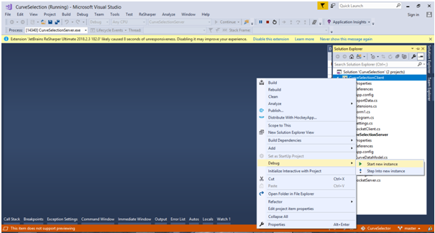

**Client Interface**

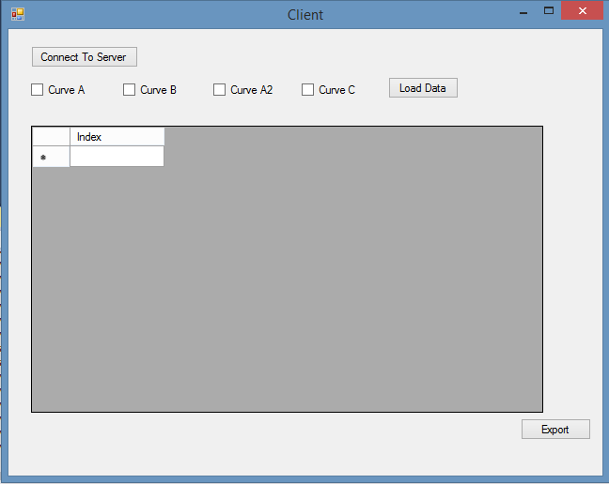

* Click the “Connect To Server”, it will establish a connection to the server
* Select at least one of the curves to load data
* “Load Data” will bind the data one by one to the grid

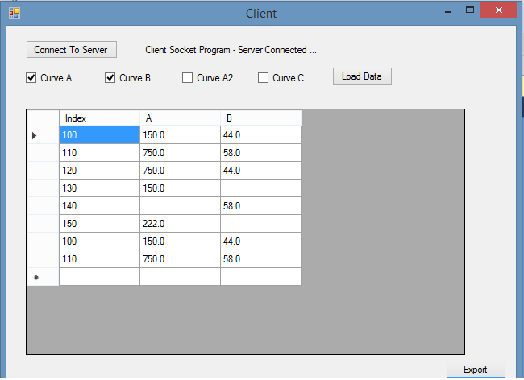

* While loading the data we can click “Export” button to download the xml file



**File Path:**

* The text file which contains the data lies in “CurveSelector\CurveSelectionServer\bin\Debug\DataFiles”. If required additional data can be added.
* The download files lies in “CurveSelector\CurveSelectionClient\Downloads”.